Numerical Analysis of Top Coal Recovery Ratio by using Discrete Element Method
Niaz Muhammad Shahani^{*1}, Zhijun Wan¹, Li Guichen¹, Fahad Irfan Siddiqui², Abdul Ghani Pathan², Yang Pei Ju¹, Liu Sifei¹
¹School of Mines, China University of Mining and Technology, Xuzhou P.R China.
²Department of Mining Engineering, Mehran University of Engineering and Technology, Jamshoro, Sindh Pakistan.
*Corresponding Author Email: shahani.niaz@gmail.com

Abstract
There is a massive quantity of lignite coal reserves at the Thar Coal Mine Pakistan which are demarcated through thick coal seams. To extract these thick coal seams, the chosen method for mining is Top Coal Caving. The Longwall Top Coal Caving (LTCC) has been one of the preferred underground mining methods that has been developed and then accepted by its guaranteed results in China’s coal mining industry. This paper discusses numerical modelling of top coal caving mining method and studies the coal recovery ratio by using discrete element method. In the modelling consequences, the total top coal recovery ratio was computed to be 83.9% when the top coal thickness was three times as the height of cutting height with the drawing interval of 0.8m respectively. Based on this study, it is proposed that LTCC method can be adopted for the mining of thick coal seam(s) at Thar Coal Mine.
Keywords: Thar coal mine; top coal caving; numerical modeling; top coal recovery ratio; thick coal seams;

- Introduction
Longwall top coal caving (LTCC) is a technique that enhances the efficiency level of production at thick coal seams ^{[1]}. LTCC was developed by combination of longwall and sublevel caving methods. The classification relating to thickness may differ from country to country but acceptable thickness is not less than 6m as the smaller margin ^{[2]}. In thick seams, bottom is mined by longwall and top coal is exploited by sublevel caving.
This method was developed in China ^{[3]} after 1982 and it is used for exploitation of thick coal seams. LTCC is a high product and low-cost method but have a high dependency to seam condition ^{[4-6]}. Capability of top coal and recovery percentage are the most important parameters in LTCC that should be completely explained and investigated ^{[7-8]}. Improving the caving ratio of top coal signifies that it can considerably increase the top coal recovery ratio of resources through productive yielding. A wide range of top coal recovery ratio can be used in LTCC method if the compactness of the seam is huge. These indicators – broken immediate roof, the recovery ratio of top coal and the movement law of fractured top coal affects the compactness of the top coal. The influence of the following parameters (– the compactness of immediate roof, cutting depth of the shearer and the mining height) – has been used by many researchers in the conduction of their researches ^{[9-14]}.
Studies that deal with the connection of both the recovery ratio of top coal and its compactness are scarce. In addition, some intriguing developments can be formed based on the above mentioned researches. This study used the PFC2D software to replicate the surroundings of how thick the top coal is, allowing it to set up numerical models. It also derived it from the theory on the field of loose medium flow ^{[15-20]}. It analyzed the effect of the recovery ratio of top coal due to the variations of its thickness. The thickness variable was used in the numerical simulation to provide the basis of the theory to obtain the recovery ratio of top coal.

- Drawing interval of top coal caving
The length from one top-coal drawing to another towards the face advancing direction is called the drawing interval. This unit is used to describe its number of cuts. For example, one cut with one mining interval, two cuts with one mining interval and three cuts with one mining interval with the mathematical values of 0.8m, 1.6m, and 2.4m correspondingly. Next, is called the cutting-caving height ratio through usual ratios are 1:2 and 1:3. As seen from Figure 1, there is a direct effect on the recovery competence and level of the working face improvement by the caving interval of top-coal. They both avert the event of a gangue in mined-out areas and surge instead to a drawing opening, dodging the influx of sublevel waste on the drawing opening as the cutting face is moving towards the top coal. A capacious caving interval of top-coal would force the sublevel waste to get the drawing opening ahead of time than the waste in the excavated-out zone. This is going to cause the drawing opening to closure. Consequently, the loss of coal behind the conveyor is going to be built up as seen in Figure 1 (a). Conversely, a small top coal caving interval would result in drawing the opening of the waste in the excavated-out area at a much earlier. The sublevel waste resulting in the blockage of the excavated-out area by a part of the top coal, as seen in Figure 1 (c). When the waste in the excavated zone and the sublevel waste arrive at the drawing opening simultaneously, the rate of top-coal loss convert into the tiniest as seen in Figure 1 (b). To get to a reasonable top coal caving interval, utilize an analogous material simulation test.
- Brief introduction of Thar coal mine
The Thar Coal Mine is positioned in district Tharparkar, province of Sindh in Pakistan. The coal reserves were exposed by Geological Survey of Pakistan (GSP), and United State Agency for international development in 1991. ^{[21]}
After the finding of Thar lignite in Sindh, Pakistan has appeared seventh number in the top-20 list of countries around the globe. The cost-effective coal deposits of Thar Pakistan are circumscribed to Paleocene and Eocene classifications of rock. It is one of the world’s largest lignite coal deposits spread over about 9,000 sq. km., contains around 175.5 billion tons which is enough to complete the fuel requirements of the country for centuries. The cumulative thickness of coal seam at Thar varies from 1.5 to 42m.
Thar coal field is divided into 12 different blocks as shown in Figure 2. The production of coal can be performed by both the open-pit and the underground mining methods in the region. Block-II out of 12-blocks is in under development phase for the open-pit mine while remaining blocks are still under planning. Especially Block-IX is considered in this study for underground method. This is the first time in the history of Pakistan the mechanized longwall with Top Coal Caving method is going to be adopt at Thar Coal. LTCC is the production efficient and low-cost development method as compared to other longwall methods like single-slice or multi-slice for thick coal seams. Figure 3 shows the highlights of LTCC method and Figure 4 indicates the general geology of Block-IX, Thar Coal Mine.
3.1 Properties of Coal and its Surrounding Rock
The effective measurement of the properties of coal and its surrounding rock mass with multiple empirical research was determined by laboratory experiments as shown in Table 1 ^{[4, 22-25]}.

Figure 1. Correspondence between caving interval and top coal recovery ratio (modified after ^{[26]}).

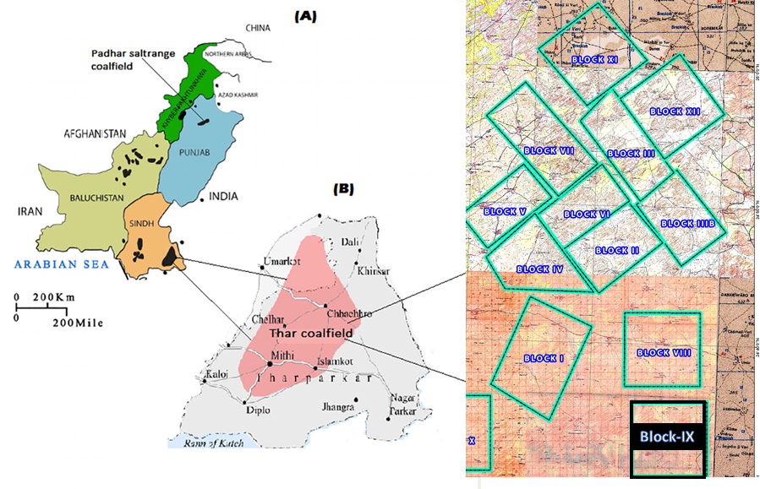
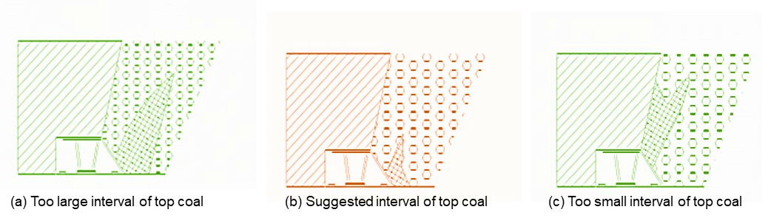

Figure 2. Location Map of Thar Coal Mine.
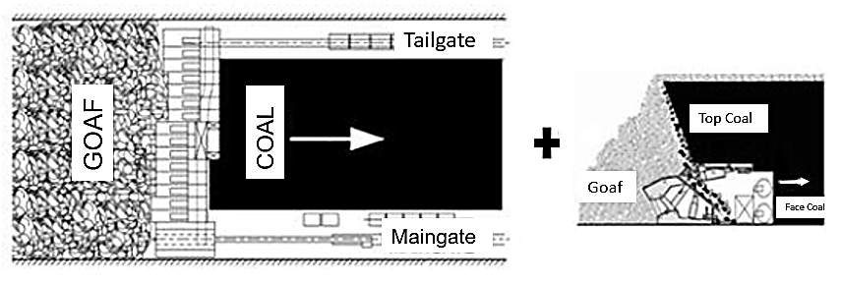

Figure 3. Highlights of LTCC method ^{[27]}.

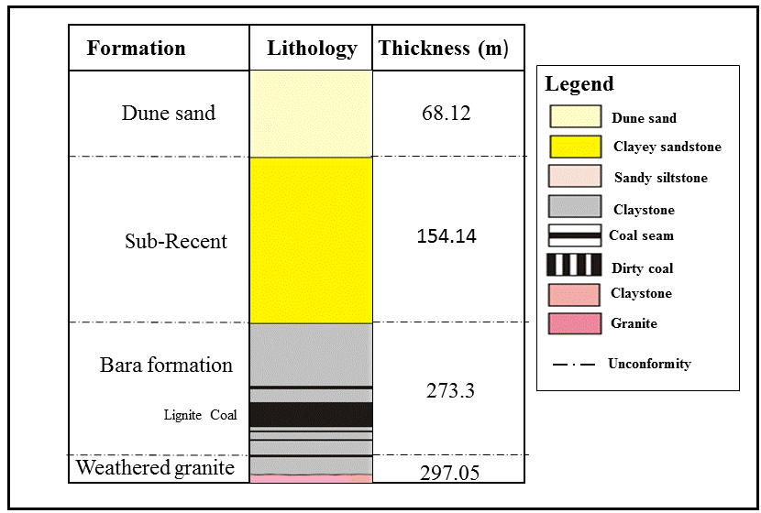
Figure 4. Generalized stratigraphic column of Block-IX Thar Coal.

- Numerical Simulation
In many circumstances, the assessment of an underground structures are considered as very challenging and costly to execute. However, the modeling with computer provides more useful, fast and real consequences to achieve. Numerical modelling was accomplished by using Particle flow code (PFC). PFC is widely used for the modeling of top coal recovery ratio and analysis the interaction of circular particles during the drawing. The software is founded on discrete element method (DEM). This research study is considered first time and its applications in thick coal seams were investigated with the help of numerical analysis using two-dimensional at Thar Coal Mine.
  - Construction of numerical block model
To be able to comprehend the mechanism of top coal drawing and recovery ratio, the PFC2D was utilized to mimic the numerical model for the caving process in two dimensions. The software allowed the modeling of the impact of the dissimilar thickness of top coal, the drawing or mining intervals and the mining practices on the top coal drawing. The PFC model uses the DEM code to simulate the synergy and movement of rounded ball particle ^{[28]}. The assumption that separately distinct particle is an inelastic with a very insignificant interaction zone was utilized in the numerical simulation process. The following are the configuration and specifications for the top coal caving of the panel in the numerical models; a 12m thick coal seam, waste rock thickness of 11m with 100m wide with different cutting to caving heights as shown in Figure 5. Table 2 shows the input parameters used in the numerical model.
In the bottom of the model are red particles defined as coal. At the top of the model are green particles defined as fractured immediate roof. The initial velocity of these particles is zero and they experience g-force at 9.81m/s². The velocity and the acceleration on the wall is zero as well. Boundary conditions of the model- outer boundaries are the adjacent barrier of the particles and the interior barrier to grip the particles. Though the acceleration and velocity are considered as zero for the boundaries.

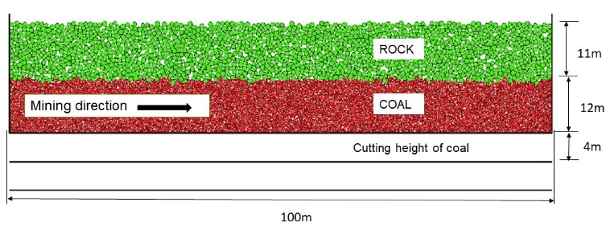
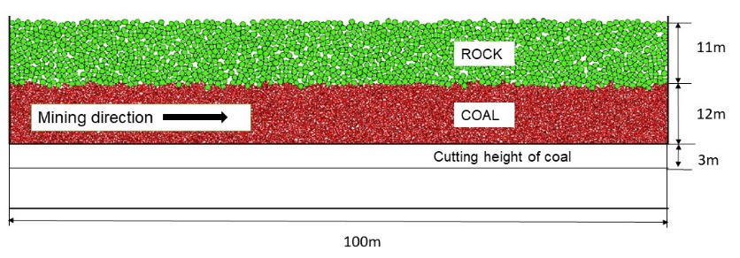
- 1:2
- 1:3
Figure 5 (and b). PFC2D numerical model for effective caving process.
Table 1. Properties of Coal and Rock.
Rock type | Unit | Claystone | Siltstone | Coal
Internal friction (φ) | (°) | 34.25 | 45 | 23.68
Cohesion (c) | (MPa) | 0.130 | 0.130 | 0.132
Modulus of elasticity (E) | (MPa) | 2119 | 2217 | 1762
Tensile strength | (MPa) | 0.365 | 0.41 | 0.217
Poisson’s (ϑ) | - | 0.25 | 0.25 | 0.28
Uniaxial compressive strength | (MPa) | 2.74 | 2.903 | 1.88

Table 2. . Input Parameters of coal and waste.
Solid | Density  (kg/m³) | Coefficient of Friction | Kn  (kN/m) | Ks  (kN/m)
Coal | 1500 | 0.4 | 2×10⁸ | 2×10⁸
Waste | 2500 | 0.4 | 4×10⁸ | 4×10⁸

Figure 6. Numerical analysis at one cut with one drawing interval (0.8m).

Table 3. Dispersal of coal seam
Seam thickness (m) | Cutting height  (m) | Cutting to caving height ratio (%) | Caving height  (m)
12 | 4 | 1:2 | 8
12 | 3 | 1:3 | 9
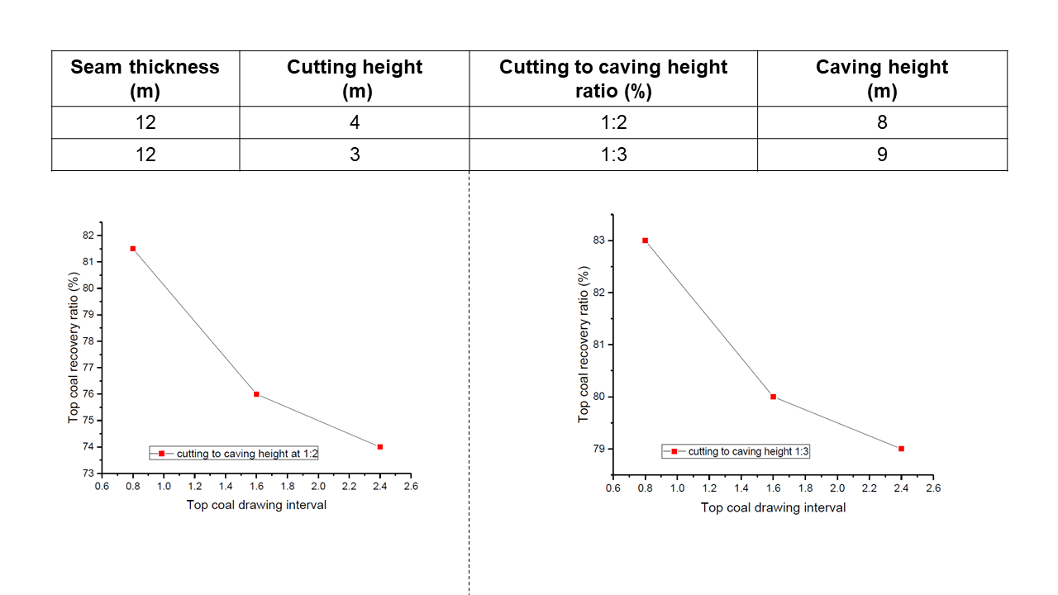
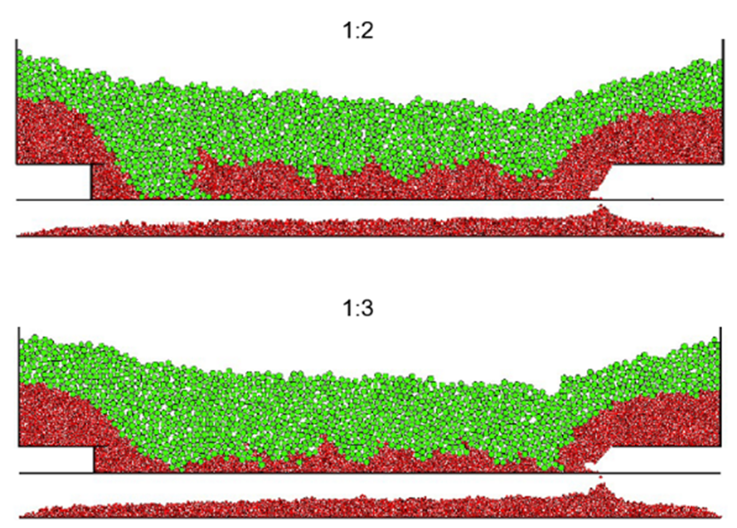

- 1:2 (b) 1:3
Figure 7 (a and b). Analysis of top coal recovery ratio.

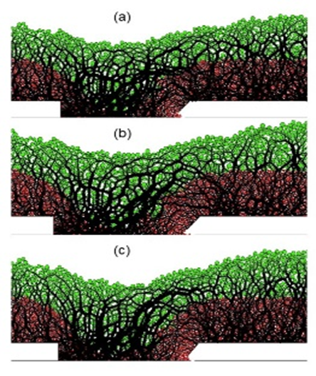
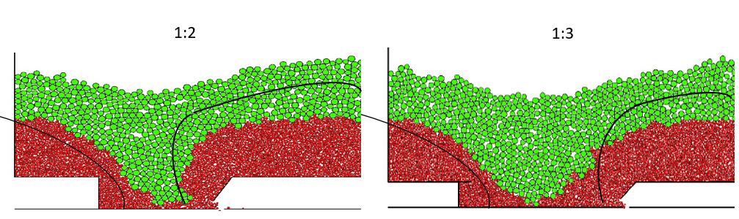
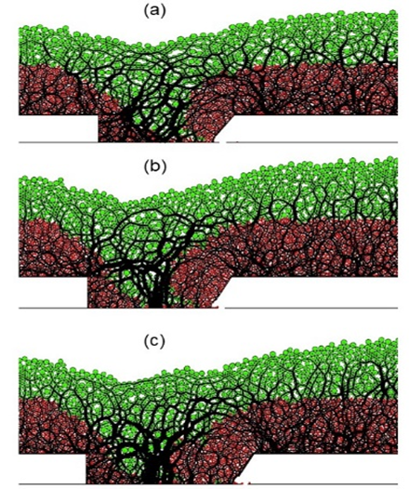
- 1:2 (b) 1:3
Figure 8. The developing of chain force during the drawing process

Figure 9 (a and b). Interface between coal and rock

- Results and discussion
To regulate the numerical modeling, the standard that the drawing growth ends once the waste rock appears out of the model is endorsed. The face advances to 76m when one cut with one drawing interval. The final result is shown in Figure 6.
To find out the top coal caving ratio during its process of advancing can be calculated by the following formula;
$\text{Rc}=\frac{Nd}{Ni}x100$ （1）
Where Rc is the top coal recovery ratio in percentage (%), Nd is the number of drawn-out coal particles, and Ni is the initial number of coal particles.
Figure 7 (a and b) and Table 3 show that the top coal recovery ratio can be affected immensely by two variables, the mining interval and cutting-caving height ratio. At different cutting-caving heights (1:2 and 1:3) and drawing intervals (0.8m, 1.6m, and 2.4m), the recovery ratio is higher with a definite cutting-caving height is 1:3 and the drawing interval is 0.8m.
Figures 8 (a and b) shows the top coal contact force recorded during the operation. Where the analysis and of the influence caused by different cutting to caving height ratios, on the distribution of coal-rock loose field.
The force chain girth represents the strength of the force among particles in the modeling of the DEM method. A wide chain of force determines the large strength of the force among the particles making it impossible for them to move. Figure 8(a) shows a cutting-caving height ratio of 1:2. The height of strong force zone moves up but the zone shows a visible arched tendency behind the goaf. Consequently, the waste rock come to the drawing opening quickly and results in a loss of top coal simultaneously. Similarly, the cutting-caving height ratio at 1:3 in Figure 8(b), the area enclosed through the chain of tight load assumes an elliptical nature that corresponds to the ideal drawn body which is helpful to the extraction of the top coal.
The structure of the drawing coal and effect on top coal caving ratio can be organized by interface between coal and rock. The discrepancies of interface between coal and rock at different cutting to caving height ratios is displayed in Figure 9(a and b). This can be divided into front and back interfaces. Back interface always remains same and front interface changes onward during the face advancing of coal. Figure 9(b) shows that the structure of interface is best for the drawing of coal in accordance to their external boundary and will increase the recovery ratio of top-coal. The waste behind the face is reached at the drawing opening during the face advancing as shown in Figure 9(a). Thus, the consequences of the interface between coal and rock at cutting-caving height of 1:2 in Figure 9(a) are not greatly ideal as compared to 1:3 in Figure 9(b).
6. Suggested cutting-caving height ratio and drawing interval for Block-IX, Thar Coal Mine
The effect of a thick and large top-coal on the top-coal recovery ratio is replicated from the deviation of the recovery ratio of top-coal. To be able to boost the recovery ratio of top-coal, the waste-rock should be stopped from the goaf and getting to the drawing opening ahead of time. Using the computations of the varied top-coal thickness conditions, the suggested cutting-caving height ratio is 1:3 instead of 1:2 at one cut with one drawing interval (0.8m) consequently. The top-coal recovery ratio commands its highest point when the top coal thickness is 9m. The past studies have also suggested the response of top coal during the caving process is in good agreement when the thickness of top coal is at 9m ^{[29]}.
- Conclusions
At present, the emphasized on longwall top coal caving method growing rapidly for the extraction of thick coal seams and it has become the key method for these thick seams. The main research areas are top-coal mechanism and the enhancement of the recovery ratio of top coal especially in the field of LTCC. The top-coal thickness may affects caving ratio of top coal.
Due to the variance in top coal thickness, the top-coal recovery ratio is biggest when the thickness of top-coal is around three times as bigger as the mining height.
The determined recovery ratio of top-coal in this study is 83.9%. The consequences of numerical simulation propose that 0.8m is the best drawing interval with cutting-caving height ratio of 1:3 was carefully demonstrated by Discrete Element Method using PFC2D 5.0 software.
However, based on the numerical modeling, the cutting to caving height 1:3 is suggested instead of 1:2 for the development of LTCC method at THAR COAL Pakistan. A 1:3 ratio means that the conventional longwall face is only 3 m high rather than 4 m high for 1:2, the reduced face height having significant face stability benefits as outlined in the past studies.
Future work
The results of present study are only based on the numerical simulation in two dimensional analysis. However, the future work can be continued on this method using three-dimensional analysis.
Acknowledgment
The author(s) want to convey their first and topmost gratitude to School of Mine, China University of Mining and Technology (CUMT) for their continuous support and dedication to accomplish this task. Additionally, authors are very much thankful to all research team members for their valuable contribution, guidance, and encouragement to complete this research work within the specified time period.
References
[1] Zhongming J. Theory of longwall top coal caving. Beijing: China Coal Industry Publishing House; 2001.
[2] Singh R. Mining methods to overcome geotechnical problems during underground working of thick coal seams-case studies. Trans Inst Min Metall (Sec A: Min Indus) 1999;108:A121–31.
[3] Wang J.C., Yang, S.L., Li, Y., Wei, L.K., and Liu, H.H. Caving mechanisms of loose top-coal in longwall top coal caving mining method. International Journal of Rock Mechanics and Mining Sciences. @014; 71 (10): 160-70
[4] Yasitli N.E. Numerical modeling of longwall with top coal caving. M.Sc. thesis, Hacettepe University, Ankara, p. 148, 2002.
[5] Cai, Y, Hebblewhite, B., Onder, U., Xu, B., Kelly, M., Wright, B., and et al. Application of longwall top coal caving to Australian operations. CSIRO–ACARP report C11040, 2003.
[6] Zhang H.G, et al. Top coal movement and cavability study at LTCC face. In: Proceedings of the longwall top coal caving technology, Beijing, 1995.
[7] Jian,W.U. Theory and practice of sub-level caving method in China [J].Journal of China Coal Society, 16(3): 1-11, 1991.
[8] WANG, J.C. The theory and technology of thick coal seam mining. [M] Metallurgical Industry Press, 2009.
[9] MENG X.R., Qiang, F.U., and Liu H.Y. Research of reasonable top-coal thickness for ligneous coal deposits in DAYAN mining area. Journal of China University of Mining & Technology, 27(4):332-335, 1998.
[10] ZHANG Y., Yan-long, S.I and Liang, SHI. The influence of large cut fully-mechanized top coal caving on recovery rate of granular top-coal mixed with inert-band hard coal. [J]. Journal of China Coal Society, 36(1): 1-6, 2011.
[11] ZHANG H.J., YAN, S.H., and Mao, D.B. Research on relationship of top coal recovery ratio and height of immediate roof with PFC numerical simulation. [J]. Coal Mining Technology, 14(6): 7-9, 2009.
[12] CHEN Qing-fens, CHEN, Z.H., and LI Hui. Experimental study in fully mechanized top coal caving law in Pingshuo mining area. [J]. Coal Engineering, 46(1): 90-93. 2014.
[13] ZHANG, Y., Yan-long, S.I, and Liang, SHI. Numerical simulation of effect of particle size of coal caving ratio. [J]. Journal of Mining & Safety Engineering, 28(2): 247-251, 2011.
[14] MAO D.B. Research on relationship of mining height recovery of top coal in fully-mechanized caving mining [J]. Coal Mining Technology, 14(4): 13-15, 2009.
[15] Zhengyang S, and Zhang, J.W. Numerical Simulation of Top-Coal Thickness Effect on the Top-Coal Recovery Ratio by Using DEM Method. EJEC Vol. 20 [2015], Bund. 9. January 2015.
[16] WANG, J.C., Qiang, F.U. The loose medium flow field theory and its application on the long wall top coal caving [J]. Journal of China Coal Society, 27(4): 337-341, 2002.
[17] WANG, J.C., Zhi-gang, L.I., and CHEN, Y.J. The experimental study of loose medium flow field on the long wall top coal caving [J]. Journal of China Coal Society, 29(3): 260-263, 2004.
[18] WANG, J.C., YANG, J.L., and Liu H.H. The practical observation on loose medium field theory on the top coal caving [J]. Journal of China Coal Society, 35(3): 353-356, 2010.
[19] Hai-yong, Y.U., and Jian, W.U. The theory and practice of top coal caving. [M] China University of Mining and Technology Press. 1992.
[20]Wang, J.C., Zhang, J.W., Song, Z.G., and Li, Z.L. Three-dimensional experimental study of loose top-coal drawing law for longwall top-coal caving mining technology. Journal of Rock Mechanics and Geotechnical Engineering. 2015.
[21] Raghu N. S., Pathan, A.G., David J. R., and Anthony S. A. Geotechnical appraisal of the thar open cut mining project, 11th underground coal operators’ conference, University of Wollongong & the Australian Institute of Mining & Metallurgy, 105-114, 2011.
[22] N.E. Yasitli, B. Unver. 3Dnumerical modeling of longwall mining with top-coal caving. International Journal of Rock Mechanics & Mining Sciences 42 (2005) 219–235. P.227, December 2014.
[23] Yasitli NE, Unver B. 3Destimation of stresses around a longwall face by using finite difference method. 18th international mining congress of Turkey, Antalya, 2003. p. 83–8.
[24] Hoek E. Strength of rock and rock masses. ISRM News J 1995;2(2):4–16.
[25] Sonmez H, Ulusay R. Modifications to the Geological Strength Index (GSI) and their applicability to stability of slopes International Journal of Rock Mechanics and Mining Sciences. 1999;36(6):743–60.
[26] He Long. Study on Weakening Technology of Top-coal and Parameter Optimization of Caving in HouAn Mine. Inner Mongolia University of Science & Technology. Thesis (in Chinese).
[27] Mustafa E. Y, et al. Numerical modelling of stress-strain analysis in underground thick coal mining. International Journal of Engineering Research and Technology, April 2018. P. 199.
[28] Liu X.G. The base on running ore. Beijing: Metallurgical Industry Press; 1995.
[29] Shahani, N.M. Numerical Modelling of Longwall Top Coal Caving Method at Thar Coal Mine. Master’s Thesis, China University of Mining and Technology, Xuzhou P.R China. 2019.

Normal stiffness
Shear stiffness

